Lab No:

0
4

✵ Lab Title: The switch and break statement in C++

o Learning objectives:
- The objectives of this lab session are:
- To understand and implement the switch statement in C++.
- To apply the break statement to control program execution.
- To use the continue statement inside loops.
- To differentiate between break and continue statements.
- To develop simple menu-driven programs using switch-case.

Theory:
Switch Statement
The switch statement is a multi-way selection control structure used to execute one block of code among multiple alternatives based on the value of a single expression.
It is commonly used as an alternative to multiple if-else statements when checking a single variable against different constant values. General Syntax:
switch(expression)
{
case constant1: statements;
break;

case constant2: statements;
break;

... default: statements;
}

• Important Rules of Switch Statement
For correct implementation, the following rules must be followed:
- The switch expression must evaluate to:
  - int o char
  - Enumeration type
(Floating-point types like float or double are not allowed.)
- Case values must be:
  - Constant expressions.
  - Unique (no duplicate case values allowed).
- The default case is optional but recommended for safe programming.
- If break is not used, execution continues into the next case (this is called fall-through behavior).

- What is break statement?
The continue statement is used inside loops. Whenever a continue statement is encountered inside a loop, control directly jumps to the beginning of the loop for next iteration, skipping the execution of statements inside loop’s body for the current iteration.
The break statement is used in following two scenarios:
  - Use break statement to come out of the loop instantly. Whenever a break statement is encountered inside a loop, the control directly comes out of loop terminating it. It is used along with if statement, whenever used inside loop (see the example below) so that it occurs only for a particular condition.
  - It is used in switch case control structure after the case blocks. Generally, all cases in switch case are followed by a break statement to avoid the subsequent cases (see the example below) execution. Whenever it is encountered in switch-case block, the control comes out of the switchcase body.

Why Break is Important?
Without break, the program continues executing the next cases even if they do not match. This may lead to incorrect results.

- Flow chart of break statement:
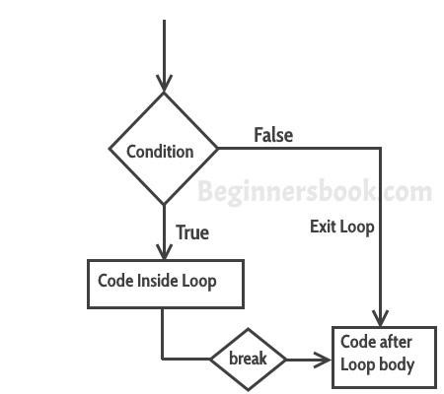

- Example: break statement in Switch Case.
#include <iostream> using namespace std; int main(){ int num=2; switch (num) { case 1: cout<<"Case 1 "<<endl; break; case 2: cout<<"Case 2 "<<endl; break; case 3: cout<<"Case 3 "<<endl; break;
default: cout<<"Default "<<endl;
}
cout<<"Hey, I'm out of the switch case"; return 0;
}

- Output:
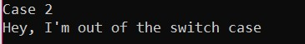
• In this example, we have break statement after each Case block, this is because if we don’t have it then the subsequent case block would also execute.

✦ The output of the same program without break would be:
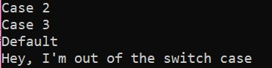
 Example: Use of break statement in a while loop.
#include <iostream> using namespace std; int main () { int var; for (var =200; var>=10; var --) { cout<<"var: "<<var<<endl; if (var==197) { break;
}
}
cout<<"Hey, I'm out of the loop"; return 0;
}

- What is continue statement?
The continue statement is used inside loops. Whenever a continue statement is encountered inside a loop, control directly jumps to the beginning of the loop for next iteration, skipping the execution of statements inside loop’s body for the current iteration.

- Flow chart of continue statement:
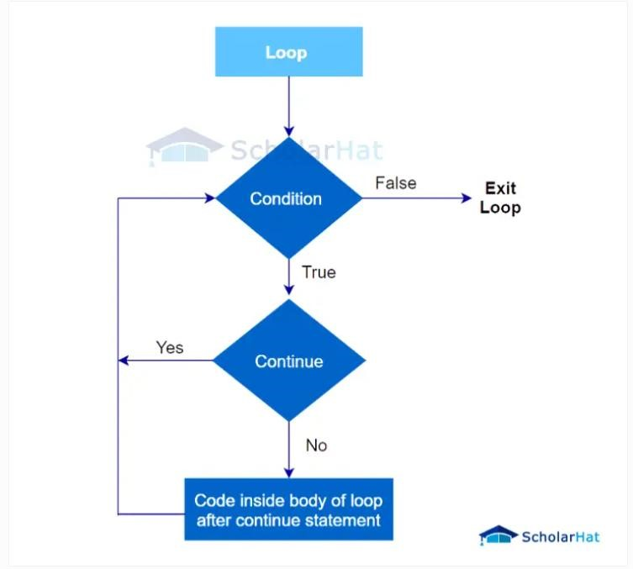

  - Example of continue statement with for loop in C++
#include <iostream> using namespace std;
int main ()
{
for (int i = 1; i <= 10; i++)
{
if (i == 5)
{
continue;
}
cout << i << endl;
}
return 0;
}

  - This C++ program iterates 10 times using a for loop.
  - The continue statement is encountered when i=5. So, it skips the remainder of the loop's body for that iteration.
  - As a result, it only prints the numbers 1-4 and 6-10, skipping 5.

- Output:
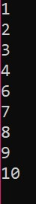

Comparison of Break and Continue Statements in C++
Parameters | break statement in C ++ | continue statement in C++
Purpose | Exits the current loop | Skips the current iteration
Applicability | Used within loops (for, while, do-while) | Used within loops (for, while, do-while)
Effect | Terminates the loop prematurely and continues with the next statement after the loop | Immediately moves to the next iteration of the loop, skipping the remaining code in the current iteration
Loop Control | Affects the entire loop | Affects only the current iteration of the loop
Typical Use Cases | When a specific condition is met, and you want to exit the loop | When you want to skip the current iteration of the loop based on a certain condition and continue with the next iteration

- Exercise:
1. Demonstrate continue statement with do...while loop in C++

- Input:
#include <iostream> using namespace std;
int main () { int num = 1;
do { if (num % 2 == 0) {
num++; continue;
}
cout << num << " "; num++;
} while (num <= 10);
cout << endl; return 0;
}

- Output:
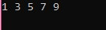

2. Demonstrate break statement with while loop in C++ ❖ Input:
#include <iostream> using namespace std;
int main() { int num = 1; while (num <= 10) { if (num == 6) {
break; } cout << num << " "; num++;
}
cout << endl; return 0;
}

- Output:
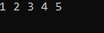

Lab Tasks
  - Task 1:
  - Write a C++ program that takes an input of a day’s number and uses a switch statement to output
  - the corresponding day’s name. Here’s how the program will proceed:
  - The program prompts the user to enter the day’s number.
  - The user enters a number between 1 and 7, where 1 is Monday and 7 is Sunday.
  - The program uses a switch statement to check which day was entered. Depending on the entered number, the corresponding day’s name is outputted using the cout statement.
  - The break statement is used to end each case statement and prevent the program from executing subsequent case statements.
  - Finally, the program returns 0 to indicate successful execution.
  - Input:
#include <iostream> using namespace std;

int main()
{ int day;
cout << "Enter day number (1-7): "; cin >> day;
switch(day)
{ case 1:
cout << "Monday"; break; case 2:
cout << "Tuesday"; break; case 3:
cout << "Wednesday"; break; case 4:
cout << "Thursday"; break; case 5:
cout << "Friday"; break; case 6:
cout << "Saturday"; break; case 7:
cout << "Sunday"; break; default:
cout << "Invalid day number";
} return 0;
}

Task 2:
Write a C++ program using switch that takes a character grade (A, B, C, D, F) from the user and prints:
A → Excellent B → Very Good C → Good D → Pass F → Fail
If any other character is entered, display "Invalid Grade"

#

#include <iostream> using namespace std;

int main()
{
char grade;

cout << "Enter your grade (A, B, C, D, F): "; cin >> grade;

switch(grade)
{ case 'A': cout << "Excellent"; break; case 'B':
cout << "Very Good";
break; case 'C':
cout << "Good"; break; case 'D': cout << "Pass"; break;
case 'F': cout << "Fail"; break; default:
cout << "Invalid Grade";
}

return 0;
}

Task 3:
Write a C++ program using switch that displays the following menu:
1 → Convert Kilometers to Meters 2 → Convert Meters to Centimeters 3 →
Convert Kilograms to Grams 4 → Convert Celsius to Fahrenheit
The program should:
Take user choice Ask for input value
Perform the selected conversion Display the result
Show "Invalid choice" if input is wrong
#

#include <iostream>
using namespace std;

int main()
{
int choice;
double value, result;

cout << "------ Unit Conversion Menu ------" << endl; cout << "1 -> Convert Kilometers to Meters" << endl; cout << "2 -> Convert Meters to Centimeters" << endl; cout << "3 -> Convert Kilograms to Grams" << endl; cout << "4 -> Convert Celsius to Fahrenheit" << endl; cout << "Enter your choice: ";
cin >> choice;

switch(choice)
{ case 1:
cout << "Enter value in Kilometers: "; cin >> value;
result = value * 1000;
cout << "Result: " << result << " meters"; break;

case 2:
cout << "Enter value in Meters: "; cin >> value; result = value * 100;
cout << "Result: " << result << " centimeters"; break;

case 3:
cout << "Enter value in Kilograms: "; cin >> value;
result = value * 1000;
cout << "Result: " << result << " grams"; break;

case 4:
cout << "Enter value in Celsius: "; cin >> value;
result = (value * 9.0/5.0) + 32;
cout << "Result: " << result << " Fahrenheit"; break;

default:
cout << "Invalid choice";
}

return 0;
}

• Conclusion
This lab experiment provided a comprehensive understanding of:
- Multi-way selection using the switch statement.
- Proper use of break to control execution flow.
- Application of continue inside loops.
- Development of structured and interactive menu-driven programs.
The experiment enhanced logical thinking and reinforced structured programming principles, which are essential for advanced software development in engineering applications.

